**Table 1**. The quality assessment scale for study recruit in current study

|  |  |
| --- | --- |
| Criteria | Score |
| Gout-type described |  |
| described | 1 |
| no described | 0 |
| Quality control of genotyping methods |  |
| DNA sequencing | 2 |
| Taqman, HRM and so on | 1 |
| RFLP | 0 |
| Habits and customs or pathogenic factors described |  |
| both described | 2 |
| only one described | 1 |
| no described | 0 |
| Source of control |  |
| Population based | 2 |
| Hospital based | 1 |
| no described | 0 |
| Case size |  |
| >=200 | 2 |
| 200>and>=100 | 1 |
| <100 | 0 |
| Hard-Weinberg equilibrium(HWE) in control |  |
| yes | 1 |
| no | 0 |

The highest quality method was selected to make assessment when more than one genotyping method occurred in one study,

146 Potentially relevant articles

99 Full text article analyze

18 Evaluated articles in detail

6 Articles meet the require

7 Articles included in meta-analysis

meta-analysis

Figure 1. Flow diagram of the literature search and selection of the study

Table 2. Principles to determine the genetic model according to the situation of OR and its P-value

|  |  |  |
| --- | --- | --- |
| Genetic Model | OR | P |
| Recessive model | OR1=OR3≠1, OR2 = 1 | POR1 and POR3<0.05, POR2>0.05 |
| Dominant model | OR1=OR2≠1, OR3 =1 | POR1 and POR2<0.05, POR3>0.05 |
| Over-dominant model | OR2= 1/OR3≠1, OR1=1 | POR2 and POR3<0.05, POR1>0.05 |
| Codominant model | OR1>OR2>1, OR1>OR3>1 | POR1, POR2 and POR3<0.05 |

OR is abbreviation for odds ratio

OR1 (TT versus GG); OR2 (GT versus GG); OR3 (TT versus GT)

**Table 3** Characteristics of studies employed in present meta-analysis

|  |  |  |  |  |  |  |  |  |  |  |  |  |
| --- | --- | --- | --- | --- | --- | --- | --- | --- | --- | --- | --- | --- |
| Study | Year | Country  of study | Continent | Ethnicity | HWE | Case/  control | Male/female Ratio  Case control | | Mean age  Case control | | MAF  Case control | |
| Woodward(white) | 2009 | USA | North America | Caucasian | No | 455/  8034 | - | - | - | - | 0.152 | 0.103 |
| Stark | 2009 | Germany | Europe | Caucasian | Yes | 677/  1552 | 2.37 | 1.26 | 58.3 | 58.5 | 0.137 | 0.104 |
| Matsuo | 2009 | Japan | Asia | Mongoloid | Yes | 159/  865 | All male | All male | - | - | 0.469 | 0.281 |
| Phipps-Green  (Maori) | 2010 | New zealand | Oceania | polynesian | Yes | 178/  212 | 2.79 | 0.48 | 39 | 40.8 | 0.107 | 0.097 |
| Phipps-Green  (Eastern Polynesia) | 2010 | - | Oceania | polynesian | Yes | 201/  210 | 2.86 | 0.50 | - | - | 0.107 | 0.090 |
| Phipps-Green  (Western Polynesia) | 2010 | - | Oceania | polynesian | Yes | 129/  71 | - | - | - | - | 0.519 | 0.275 |
| Phipps-Green (Caucasian) | 2010 | New zealand | - | Caucasian | Yes | 211/  558 | 6.25 | 0.69 | 46.2 | 44.6 | 0.242 | 0.126 |
| Phipps-Green  (Pacific Island) | 2010 | New zealand | Oceania | polynesian | Yes | 173/  109 | 22.3 | 1.18 | 33.5 | 37.7 | 0.439 | 0.202 |
| Yamagishi | 2010 | Japan | Asia | Mongoloid | No | 45/  3878 | 4.60 | 0.63 | - | - | 0.467 | 0.311 |
| Li | 2011 | China | Asia | Mongoloid | Yes | 200/  235 | All male | All male | 56.0 | 42.3 | 0.453 | 0.323 |
| Guan | Unpub | China | Asia | Mongoloid | Yes | 201/  200 | 11.56 | 0.70 | 58 | 51 | 0.54 | 0.30 |

Unpu means this study have not published before.

MAF is abbreviation for minor allele frequency.

**Table 4**. Determination of genetic model in different subgroups.

|  |  |  |  |  |  |  |  |  |  |  |  |  |
| --- | --- | --- | --- | --- | --- | --- | --- | --- | --- | --- | --- | --- |
|  | | | OR1 | | | OR2 | | | OR3 | | | Suggest model |
|  | condition | subjects | OR | 95%CI | P | OR | 95%CI | P | OR | 95%CI | P |  |
| **Overall** | 11 | 4.30 | 3.069-6.037 | 0.00 | 1.70 | 1.405-2.059 | 0.00 | 2.36 | 1.707-3.250 | 0.00 | **codominant** |
| Year | **2009** | 3 | 2.81 | 1.765-4.484 | 0.00 | 1.82 | 1.252-2.652 | 0.00 | 1.34 | 0.942-1.920 | 0.10 | dominant |
| **2010** | 6 | 5.78 | 3.672-9.084 | 0.00 | 1.70 | 1.233-2.350 | 0.00 | 3.13 | 1.997-4.907 | 0.00 | **codominant** |
| **2011-** | 2 | 5.29 | 2.488-11.230 | 0.00 | 1.50 | 1.103-2.036 | 0.01 | 3.47 | 2.187-5.521 | 0.00 |
| HWE | **Yes** | 9 | 4.83 | 3.290-7.087 | 0.00 | 1.76 | 1.377-2.241 | 0.00 | 2.48 | 1.673-3.675 | 0.00 |
| **No** | 2 | 2.89 | 1.725-4.859 | 0.00 | 1.55 | 1.259-1.908 | 0.00 | 2.04 | 1.031-4.022 | 0.04 |
| Continent | **Non-Asian** | 7 | 4.15 | 2.222-7.759 | 0.00 | 1.63 | 1.322-2.015 | 0.00 | 2.10 | 1.422-3.107 | 0.00 |
| **Asian** | 4 | 4.56 | 3.235-6.429 | 0.00 | 1.80 | 1.172-2.778 | 0.01 | 2.54 | 1.442-4.479 | 0.00 |
| Sample size | **>1000** | 4 | 3.07 | 2.141-4.397 | 0.00 | 1.74 | 1.255-2.408 | 0.00 | 1.58 | 1.104-2.256 | 0.01 |
| **<1000** | 7 | 5.95 | 4.067-8.694 | 0.00 | 1.68 | 1.294-2.178 | 0.00 | 3.39 | 2.406-4.775 | 0.00 |
| Ethnicity | **Caucasian** | 3 | 2.80 | 1.513-5.182 | 0.00 | 1.61 | 1.308-1.975 | 0.00 | 1.66 | 1.042-2.648 | 0.03 |
| **Mongoloid** | 4 | 4.56 | 3.235-6.429 | 0.00 | 1.80 | 1.172-2.778 | 0.01 | 2.54 | 1.442-4.479 | 0.00 |
| **Polynesian** | 4 | 8.20 | 4.008-16.791 | 0.00 | 1.67 | 1.030-2.704 | 0.04 | 3.66 | 1.791-7.498 | 0.00 |
| Quality | **Low** | 4 | 3.83 | 1.927-7.617 | 0.00 | 1.56 | 1.206-2.011 | 0.00 | 2.25 | 1.420-3.555 | 0.00 |
| **High** | 7 | 4.59 | 3.052-6.894 | 0.00 | 1.78 | 1.353-2.332 | 0.00 | 2.40 | 1.534-3.750 | 0.00 |
| Gender | **Male** | 6 | 4.02 | 2.948-5.477 | 0.00 | 1.84 | 1.351-2.509 | 0.00 | 2.06 | 1.274-3.329 | 0.00 |
| **Female** | 4 | 4.20 | 1.981-8.918 | 0.00 | 1.26 | 0.805-1.962 | 0.31 | 4.17 | 1.118-15.579 | 0.03 | recessive |
| **Overall** | 10 | 4.04 | 3.032-5.384 | 0.00 | 1.68 | 1.286-2.182 | 0.00 | 2.34 | 1.467-3.746 | 0.00 | **codominant** |
| Age | **>46** | 5 | 4.20 | 3.153-5.598 | 0.00 | 1.69 | 1.218-2.349 | 0.00 | 2.29 | 1.392-3.780 | 0.00 |
| **<46** | 3 | 7.33 | 3.768-14.266 | 0.00 | 1.81 | 1.114-2.940 | 0.02 | 3.16 | 1.597-6.239 | 0.00 |
| **Overall** | 8 | 4.66 | 3.583-6.054 | 0.00 | 1.74 | 1.348-2.234 | 0.00 | 2.45 | 1.668-3.612 | 0.00 |

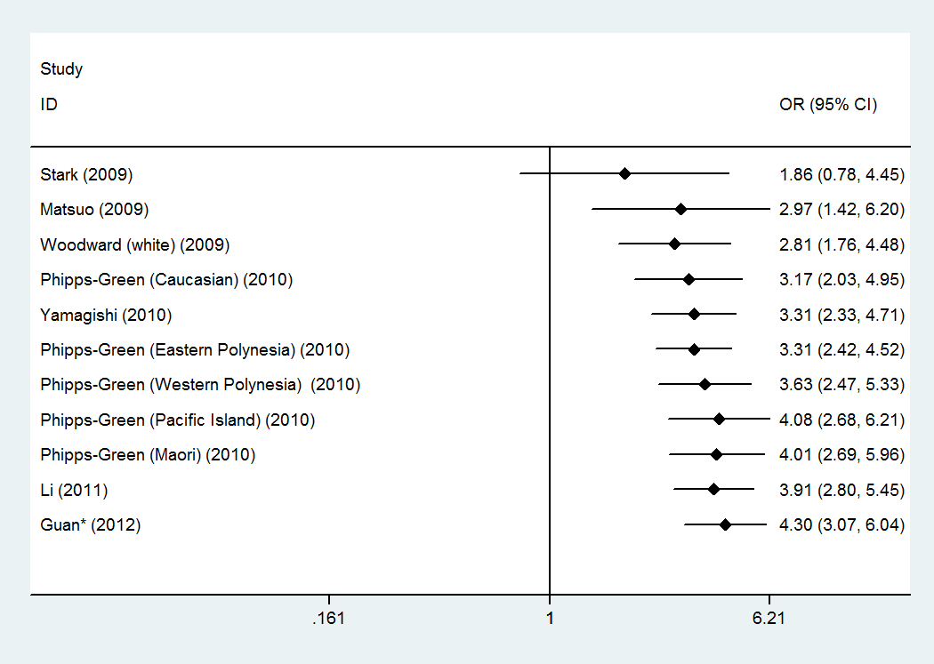

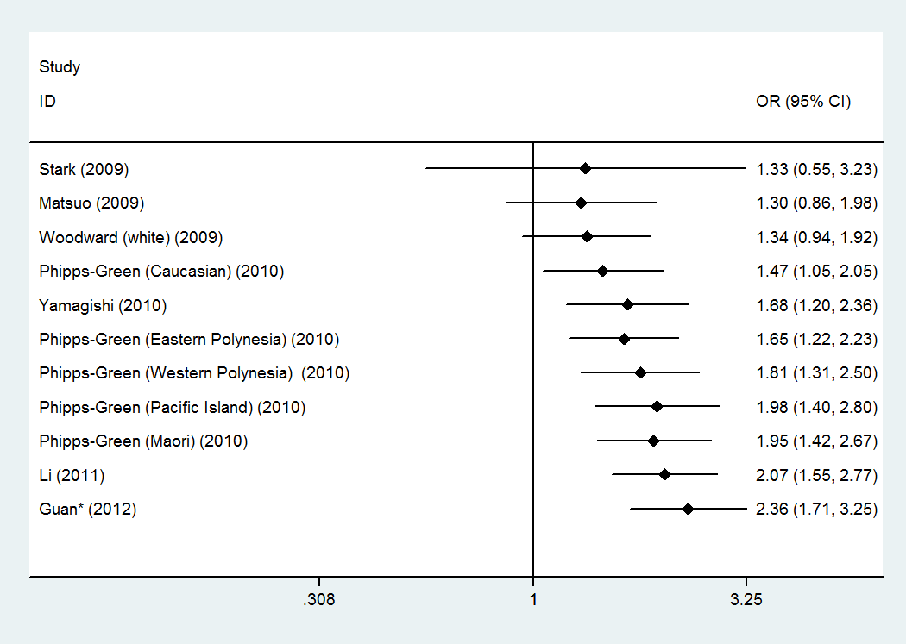

Figure 2. Cumulative meta-analysis of associations between the SNP rs2231142 and gout sorted primarily by published year with codominant model. (A) TT versus GG; (B) TT versus GT. *We default the Guan’s study published in 2012 in cumulative meta-analysis.

**Figure 3**. Percentages of rs2231142 T allele and genotypes in different years (A in cases, B in controls).

**Table 5**. Meta-regression analysis in codominant model

|  |  |  |  |  |  |  |  |  |  |  |
| --- | --- | --- | --- | --- | --- | --- | --- | --- | --- | --- |
|  | Log(OR) | t | P>|t| | [95% Conf. Interval] | | I2 | ^I2 | Tau2 | ^Tau2 | R2 |
| TT versus  GG | Sex | -0.44 | 0.67 | -1.20057 | 0.8143707 | 0 | 5.13% | 0 | 0 | 0% |
| **Year\*** | 1.97 | **0.08** | -0.040956 | 0.6035375 | 40.50% | 21.51% | 0.1182 | 0.05429 | 59.01% |
| HWE | 1.24 | 0.245 | -0.405668 | 1.397079 | 40.50% | 35.62% | 0.1182 | 0.1111 | 16.13% |
| Continent | 0.33 | 0.752 | -0.720659 | 0.9627413 | 40.50% | 44.50% | 0.1182 | 0.1675 | -26.51% |
| Age* | -1.33 | 0.231 | -0.08072 | 0.0237599 | 34.40% | 29.72% | 0.0819 | 0.07339 | 7.96% |
| Quality | 0.49 | 0.633 | -0.6935492 | 1.081059 | 40.50% | 43.36% | 0.1182 | 0.1562 | -17.95% |
| Quality* | 0.07 | 0.943 | -0.3841871 | 0.4097663 | 40.50% | 45.93% | 0.1182 | 0.1804 | -36.23% |
| Sample size* | -2.12 | 0.063 | -0.000234 | 7.69E-06 | 40.50% | 18.33% | 0.1182 | 0.04515 | 65.91% |
| Ethnicity& |  |  |  |  | 43.26% |  | 0.13 | 0.0299 | 77% |
| TT versus  GT | Sex | -0.92 | 0.386 | -2.035447 | 0.876886 | 51.90% | 53.33% | 0.2512 | 0.2143 | -8.91% |
| **Year\*** | 3.49 | **0.007** | 0.1361756 | 0.6397529 | 37.90% | 0.00% | 0.1014 | 0 | 100.00% |
| HWE | 0.46 | 0.656 | -0.767962 | 1.161357 | 37.90% | 43.31% | 0.1014 | 0.149 | -20.32% |
| Continent | 0.34 | 0.744 | -0.690765 | 0.9322637 | 37.90% | 43.56% | 0.1014 | 0.1477 | -19.32% |
| Age* | -1.32 | 0.235 | -0.084776 | 0.0253756 | 48.10% | 35.79% | 0.1365 | 0.1042 | 25.74% |
| Quality | 0.05 | 0.959 | -0.8548063 | 0.8957059 | 37.90% | 44.11% | 0.1014 | 0.1508 | -21.75% |
| Quality* | -0.65 | 0.529 | -0.4705011 | 0.2592886 | 37.90% | 38.46% | 0.1014 | 0.1384 | -11.77% |
| Sample size* | -1.22 | 0.254 | -0.000225 | 0.0000674 | 37.90% | 35.00% | 0.1014 | 0.1196 | 3.43% |
| Ethnicity& |  |  |  |  | 42.71% |  | 0.12 | 0.1180 | 1.67% |
| GT versus  GG | Sex | 1.25 | 0.246 | -0.32009 | 1.08196 | 58.30% | 56.41% | 0.0892 | 0.07485 | 9.15% |
| Year* | -0.43 | 0.679 | -0.33186 | 0.22622 | 60.40% | 64.39% | 0.0567 | 0.08147 | -21.29% |
| HWE | 0.57 | 0.582 | -0.47411 | 0.794375 | 60.40% | 63.82% | 0.0567 | 0.08001 | -19.12% |
| Continent | 0.43 | 0.675 | -0.42415 | 0.625464 | 60.40% | 61.70% | 0.0567 | 0.07543 | -12.30% |
| Age* | 0.07 | 0.944 | -0.03719 | 0.039474 | 67.00% | 71.64% | 0.0833 | 0.1079 | -24.47% |
| Quality | 0.53 | 0.607 | -0.401802 | 0.649492 | 60.40% | 63.71% | 0.0567 | .07686 | -14.43% |
| Quality* | 1.12 | 0.291 | -0.1145065 | 0.3400154 | 60.40% | 60.94% | 0.0567 | .06363 | 5.27% |
| Sample size* | -0.49 | 0.634 | -0.00011 | 7.27E-05 | 60.40% | 63.43% | 0.0567 | 0.08197 | -22.04% |
| Ethnicity& |  |  |  |  | 64.43% |  | 0.07 | 0.0944 | -34.86% |

* means those factors were treated as Continuous variables.

^ means the results analyzed by meta-regression analysis.

& means R software was used for meta-regression analysis.

In the meta-regression analysis of published year, we default the Guan’s study published in 2012.

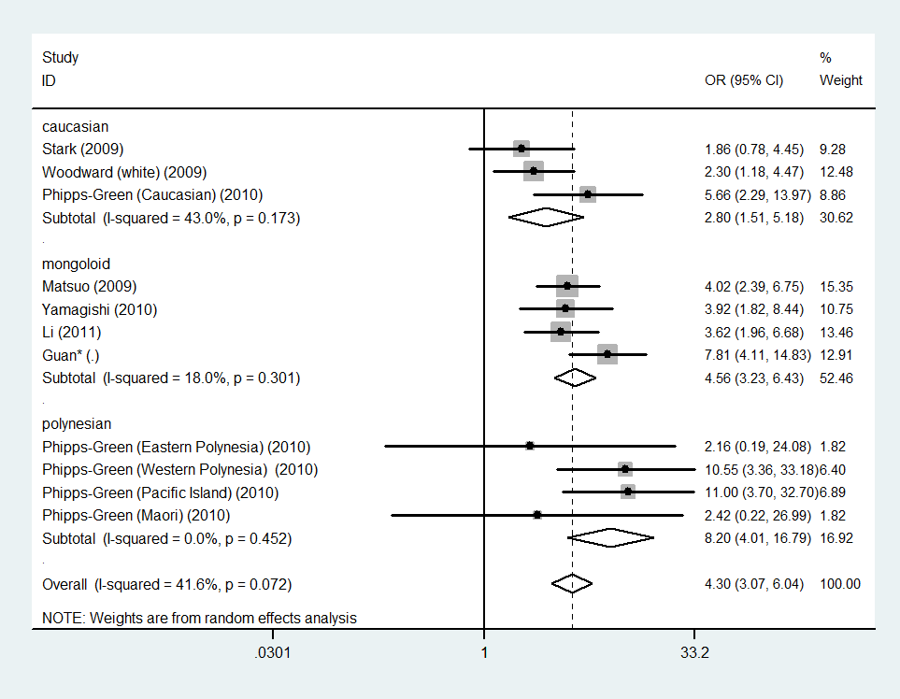

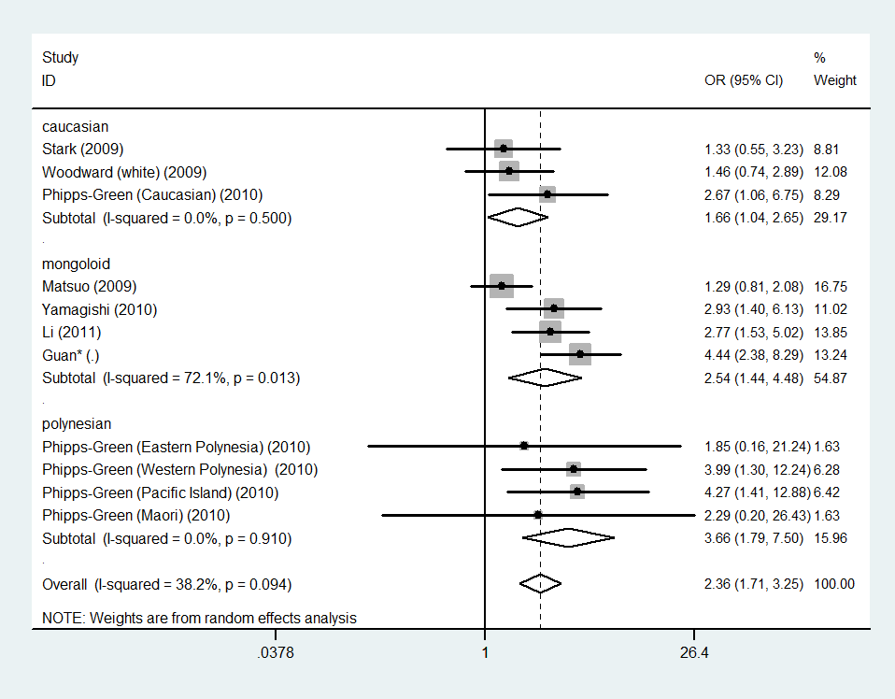

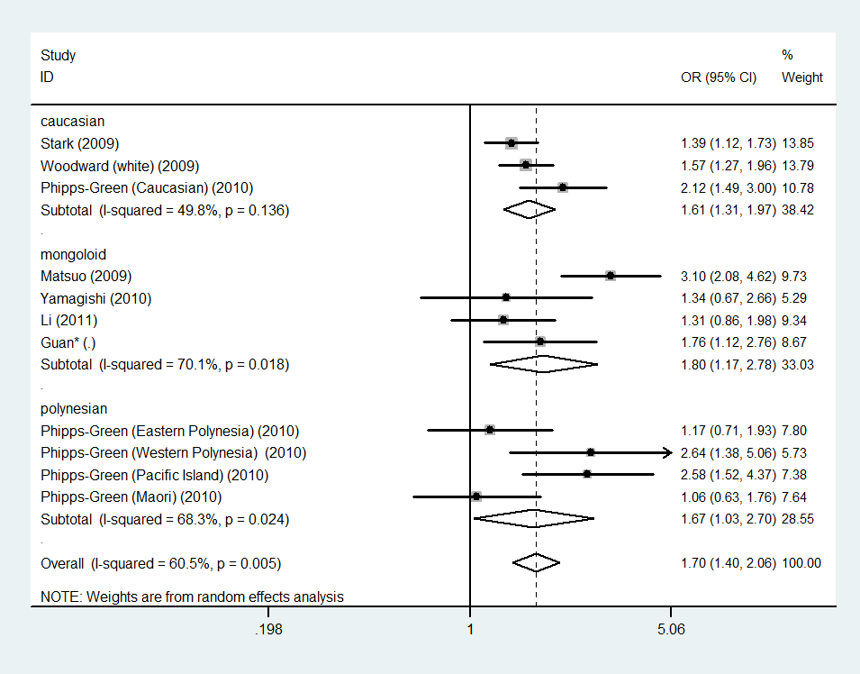

Figure 4. The forest plots for rs2231142 with gout in codominant model in different ethnicities.

(A) TT versus GG (B) TT versus GT ; (C) GT versus GG.*means the study of Guan is unpublished.

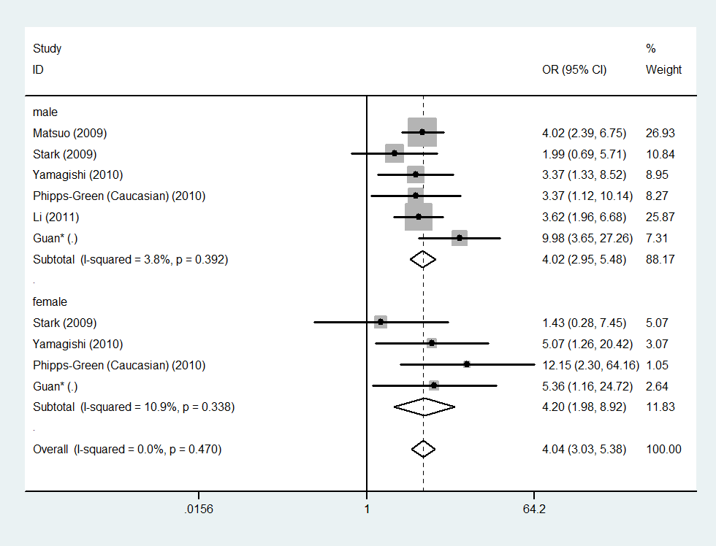

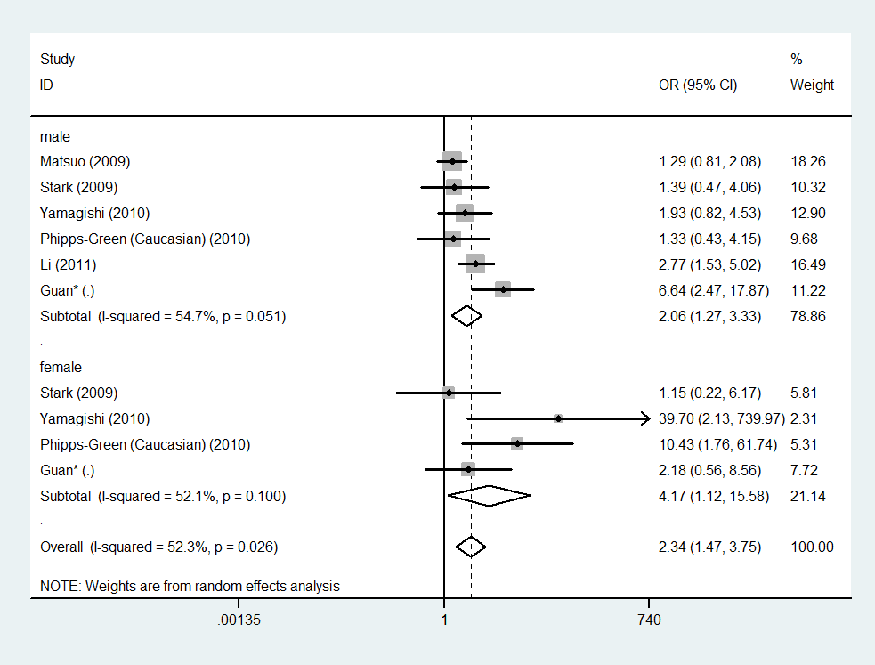

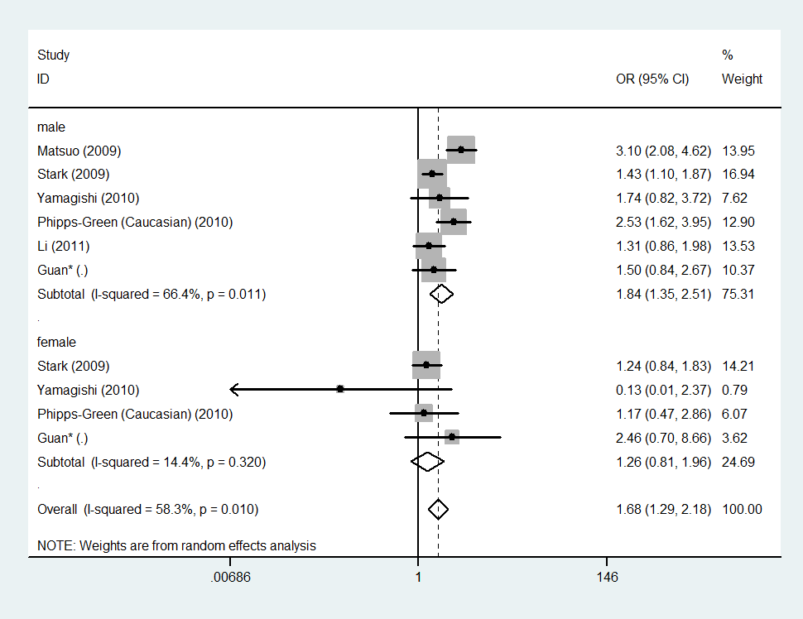

Figure 5. Forest plots for rs2231142 with gout in codominant model in different gender.

(A) TT versus GG; (B) TT versus GT ; (C) GT versus GG;*means the study of Guan is unpublished.

**Figure 6**. Percentages of rs2231142 T allele, genotypes and gout prevalence in different populations.

S.Table 1. Characteristics of studies employed in meta-analysis

|  |  |  |  |  |  |  |  |  |  |  |  |  |  |
| --- | --- | --- | --- | --- | --- | --- | --- | --- | --- | --- | --- | --- | --- |
| Study | Year | Control source | Quality score | Genotyping method | Gout type | Other describe | TT | GT | GG | TTC | GTC | GGC | Ref |
| Woodward(white) | 2009 | Pb | 5 | TaqMan | - | N | 10 | 118 | 327 | 86 | 1483 | 6465 | 8 |
| Stark | 2009 | Hb | 7 | TaqMan | - | Y | 9 | 168 | 500 | 12 | 299 | 1241 | 32 |
| Matsuo | 2009 | Pb | 8 | Sequencing and Taqman/ HRM | primary | Y | 31 | 87 | 41 | 87 | 316 | 462 | 1 |
| Phipps-Green  (Maori) | 2010 | Pb | 6 | TaqMan | - | Y | 2 | 34 | 142 | 1 | 39 | 172 | 17 |
| Phipps-Green  (Eastern Polynesia) | 2010 | Pb | 5 | TaqMan | - | N | 2 | 39 | 160 | 1 | 36 | 173 | 17 |
| Phipps-Green  (Western Polynesia) | 2010 | Pb | 5 | TaqMan | - | N | 34 | 66 | 29 | 4 | 31 | 36 | 17 |
| Phipps-Green (Caucasian) | 2010 | Pb | 7 | TaqMan | - | Y | 13 | 76 | 122 | 8 | 125 | 425 | 17 |
| Phipps-Green  (Pacific Island) | 2010 | Pb | 6 | TaqMan | - | Y | 37 | 78 | 58 | 4 | 36 | 69 | 17 |
| Yamagishi | 2010 | Pb | 5 | energy transfer probe method | - | Y | 12 | 18 | 15 | 377 | 1655 | 1846 | 33 |
| Li | 2011 | Hb | 7 | SNapshot | primary | Y | 45 | 91 | 64 | 20 | 112 | 103 | 34 |
| Guan | Unpub | Hb | 7 | HRM and sequencing | - | Y | 67 | 82 | 52 | 16 | 87 | 97 | - |

Other describes included habits, customs and pathogenic factors.

Pb: Population based. Hb: Hospital based.

S.Table 2 Meta-analysis for rs2231142 associated with gout in other genetic models

|  |  |  |  |  |  |  |  |  |  |  |  |  |  |  |
| --- | --- | --- | --- | --- | --- | --- | --- | --- | --- | --- | --- | --- | --- | --- |
|  |  |  | Dominant model | | | | Recessive model& | | | | Overdominant model | | | |
|  | condition | subjects | OR | 95%CI | P | P* | OR | 95%CI | P | P* | OR | 95%CI | P | P* |
| Overall# |  | 11 | 1.98 | 1.581-2.486 | 0.00 | 0.00 | 3.36 | 2.706-4.180 | 0.00 | 0.14 | 0.74 | 0.625-0.888 | 0.00 | 0.01 |
| Case/Control | <0.5 | 5 | 1.96 | 1.458-2.624 | 0.00 | 0.00 | 2.44 | 1.833-3.256 | 0.00 | 0.43 | 0.63 | 0.516-0.778 | 0.00 | 0.06 |
| >0.5and<1 | 3 | 1.35 | 1.038-1.754 | 0.03 | 0.37 | 3.02 | 1.765-5.165 | 0.00 | 0.93 | 0.99 | 0.762-1.281 | 0.93 | 0.75 |
| >1 | 3 | 3.09 | 2.320-4.111 | 0.00 | 0.69 | 6.09 | 3.820-9.720 | 0.00 | 0.94 | 0.82 | 0.551-1.209 | 0.31 | 0.14 |
| HWE | yes | 9 | 2.07 | 1.551-2.750 | 0.00 | 0.00 | 3.53 | 2.763-4.518 | 0.00 | 0.11 | 0.74 | 0.602-0.918 | 0.01 | 0.01 |
| no | 2 | 1.63 | 1.336-1.995 | 0.00 | 0.72 | 2.61 | 1.641-4.164 | 0.00 | 0.31 | 0.79 | 0.471-1.321 | 0.37 | 0.09 |
| Continent | non-asian | 7 | 1.82 | 1.385-2.388 | 0.00 | 0.00 | 3.49 | 2.427-5.026 | 0.00 | 0.23 | 0.68 | 0.600-0.767 | 0.00 | 0.43 |
| asian | 4 | 2.33 | 1.656-3.272 | 0.00 | 0.07 | 3.29 | 2.508-4.315 | 0.00 | 0.08 | 0.88 | 0.552-1.406 | 0.60 | 0.00 |
| Sample size | >1000 | 4 | 1.87 | 1.332-2.640 | 0.00 | 0.00 | 2.25 | 1.656-3.058 | 0.00 | 0.60 | 0.66 | 0.527-0.838 | 0.00 | 0.07 |
| <1000 | 7 | 2.06 | 1.493-2.832 | 0.00 | 0.00 | 4.64 | 3.351-6.426 | 0.00 | 0.68 | 0.81 | 0.628-1.044 | 0.10 | 0.04 |
| Ethnicity | caucasian | 3 | 1.69 | 1.319-2.171 | 0.00 | 0.05 | 2.45 | 1.569-3.819 | 0.00 | 0.27 | 0.65 | 0.546-0.764 | 0.00 | 0.25 |
| mongoloid | 4 | 2.33 | 1.656-3.272 | 0.00 | 0.07 | 3.29 | 2.508-4.315 | 0.00 | 0.08 | 0.88 | 0.552-1.406 | 0.60 | 0.00 |
| polynesian | 4 | 1.97 | 1.050-3.700 | 0.04 | 0.00 | 5.72 | 2.886-11.346 | 0.00 | 0.72 | 0.78 | 0.600-1.009 | 0.06 | 0.61 |
| Quality | low | 4 | 1.79 | 1.241-2.569 | 0.00 | 0.06 | 3.23 | 2.128-4.895 | 0.00 | 0.38 | 0.74 | 0.593-0.913 | 0.01 | 0.32 |
| high | 7 | 2.09 | 1.527-2.855 | 0.00 | 0.00 | 3.41 | 2.642-4.393 | 0.00 | 0.07 | 0.73 | 0.569-0.944 | 0.02 | 0.00 |
| Gender | male | 6 | 2.14 | 1.582-2.888 | 0.00 | 0.01 | 2.92 | 2.214-3.852 | 0.00 | 0.22 | 0.73 | 0.518-1.030 | 0.07 | 0.00 |
| female | 4 | 1.36 | 0.989-1.879 | 0.06 | 0.51 | 4.07 | 1.986-8.329 | 0.00 | 0.19 | 0.88 | 0.550-1.411 | 0.60 | 0.28 |
| overall | 10 | 1.93 | 1.499-2.477 | 0.00 | 0.01 | 3.02 | 2.332-3.919 | 0.00 | 0.15 | 0.77 | 0.585-1.011 | 0.06 | 0.00 |
| Age | >46 | 5 | 2.52 | 1.354-4.696 | 0.00 | 0.00 | 3.10 | 2.398-4.017 | 0.00 | 0.08 | 0.83 | 0.604-1.148 | 0.26 | 0.00 |
| <46 | 3 | 2.07 | 1.150-3.720 | 0.02 | 0.01 | 5.44 | 2.805-10.552 | 0.00 | 0.65 | 0.64 | 0.448-0.921 | 0.02 | 0.14 |
| overall | 8 | 2.34 | 1.536-3.567 | 0.00 | 0.00 | 3.40 | 2.680-4.323 | 0.00 | 0.11 | 0.76 | 0.597-0.969 | 0.03 | 0.00 |

& mean all meta-analysis in recessive model used fixed-effects model.

#means the pool result for all 11 subjects after meta-analysis.

* means P-value for heterogeneity.

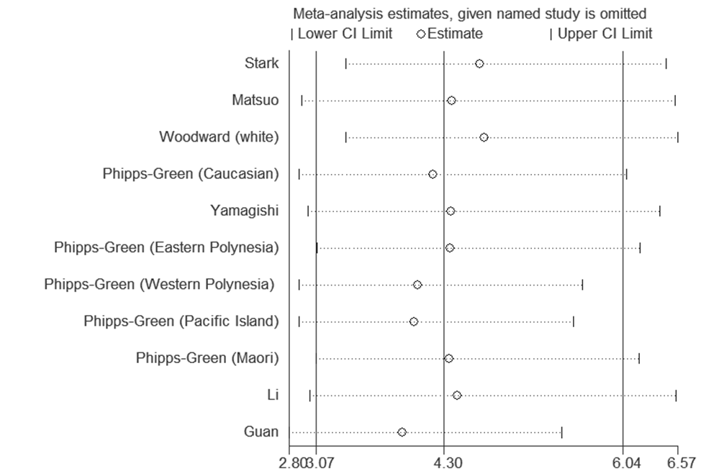

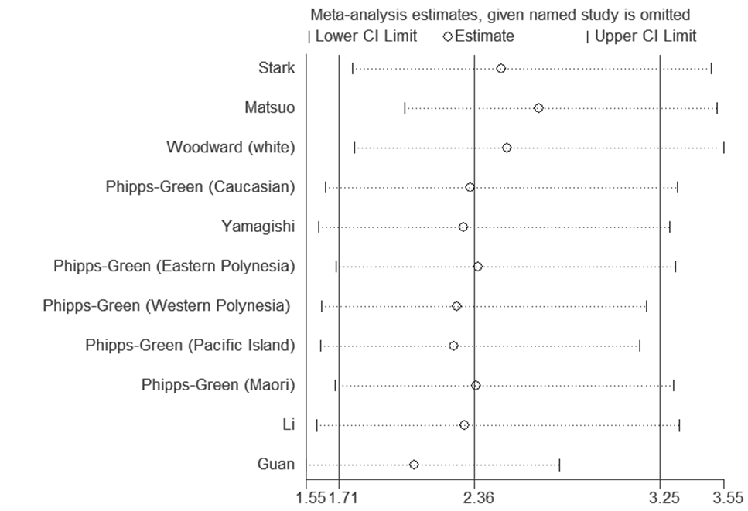

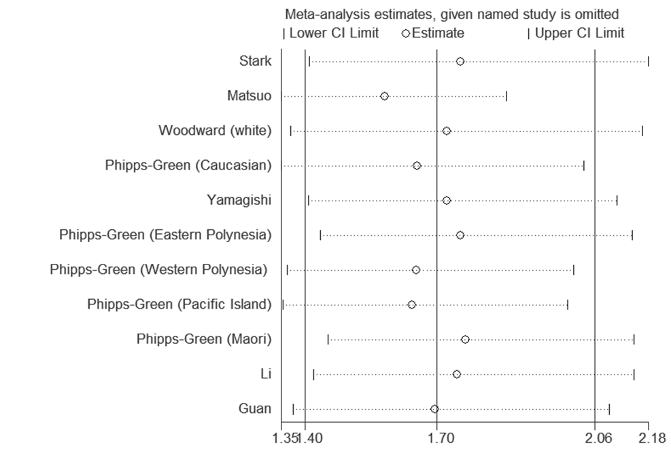

S.Figure 1. Influence analysis of the summary odds ratio coefficients on the association for rs2231142 with gout (A)in codominant model (TT versus GG) (B)in codominant model (TT versus GT) ; (C) in codominant model (GT versus GG).